February 4, 1916

Islam Eliminated all Forms of Institutionalized Exploitation Including Usury
I bear witness that none deserves to be served besides Allah and I bear witness that Muhammad is the servant and messenger of Allah. —
After this, I seek the protection of Allah from the accursed devil.
In the name of Allah, the Beneficent, the Merciful.
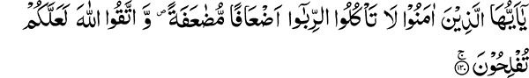
“O you who believe, devour not usury, doubling and redoubling, and keep your duty to Allah, that you may be successful.” (3:130)
“And guard yourselves against the fire which has been prepared for the disbelievers.” (3:131)
“And obey Allah and the Messenger, that you may be shown mercy.” (3:132)
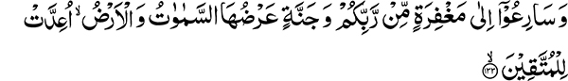
“And hasten to forgiveness from your Lord and a Garden, as wide as the heavens and the earth; it is prepared for those who keep their duty.” (3:133)
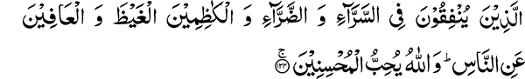
“Those who spend in ease as well as in adversity and those who restrain (their) anger and pardon men. And Allah loves the doers of good (to others).” (3:134)
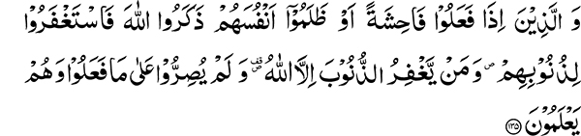
“And those who, when they commit an indecency or wrong their souls, remember Allah and ask forgiveness for their sins. And who forgives sins but Allah? And they persist not knowingly in what they do.” (3:135)
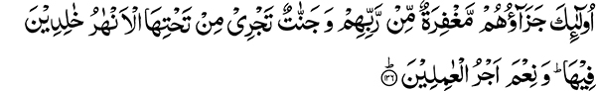
“Their reward is protection from their Lord, and Gardens wherein flow rivers, to abide in them. And excellent is the reward of the workers!” (3:136)
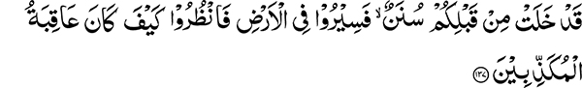
“Indeed there have been examples before you; so travel in the earth and see what was the end of the deniers.” (3:137)

“This is a clear statement for men, and a guidance and an admonition to those who would keep their duty.” (3:138)
“And be not weak-hearted, nor grieve, and you will have the upper hand if you are believers.” (3:139)
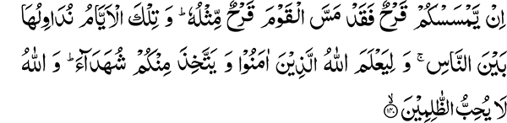
“If a wound has afflicted you, a wound like it has also afflicted the (disbelieving) people. And We bring these days to men by turns, that Allah may know those who believe and take witnesses from among you. And Allah loves not the wrongdoers,” (3:140)
“And that He may purge those who believe and deprive the disbelievers of blessings.” (3:141)
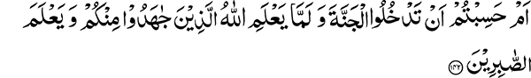
“Do you think that you will enter the Garden while Allah has not yet known those from among you who strive hard (nor) known the steadfast?” (3:142)
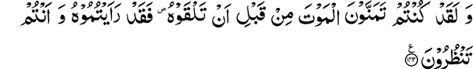
“And certainly you desired death before you met it. So indeed you have seen it now while you look (at it).” (3:143)

Holy Quran is a Complete Book
The Holy Quran is an amazing Book, a single chapter of which covers an immense variety of subjects. Before this section, the discussion was with the Christians and strong arguments were presented to refute the divinity of Jesus. After these, were prophecies that God will make Muslims the best of nations, and that it was their duty now to guide people towards righteousness and forbid evil. This was followed by events related to war, and now a different subject is addressed. All of this provides evidence that the Holy Quran is a complete Book. The question of arrangement is a different topic and calls for a separate discussion. The Quranic objective for discussing such a variety of topics is to strengthen all of man’s spiritual faculties.

Islam is the Essence of all Faiths
Mankind has been endowed with various faculties and is a minor universe unto himself, containing the essence of all creation. Similarly, any good that is found in other religions exists in Islam in its most complete and developed form. On one hand it openly and actively carries on a debate with other religions, and at the same time it incorporates principles of monasticism. What is the lesson we learn from our daily prayers? They present a picture of monastic life, but in this case, rather than retreating into the jungle, one spares time from his daily occupation to pray five times a day. Monasticism is a onetime sacrifice, while keeping up prayers calls for sacrifice on a daily basis. So if another religion has called monasticism a preferred way of life, its best and most highly developed form is found in Islam. If it is a noble deed to pray in seclusion, then Islam also enjoins us to get up in the middle of the night when nobody sees or hears us and supplicate before the Lord. If open expression is commendable, then Allah the Most High has commanded the five daily obligatory prayers preferably in congregation. Similarly, fighting in self-defense in a most sacred manner is also endorsed by the teachings of Islam.

Essential Clarifications Regarding Warfare
People think of war as a barbarism. Those who have not studied the life history of the Holy Prophet or his companions immediately accuse them of war mongering. What they do not ask is the valid question, ‘is war under all circumstances a faulty undertaking?’ War waged to inflict injury or rob someone is indeed the work of bandits. However, the person who wishes to eliminate all form of warfare and its tools is also trying to accomplish the impossible and goes against the very nature of man. There have always been differences between men, and there will always continue to be, therefore war is a necessary outcome. Today, our own government has to face war. In this conflict we praise those who leave their homes and, without caring for their own safety, bravely go out to fight the enemy.
War for the Sake of Religious Freedom and Preservation of Human Rights is Commendable
If war is commendable today under the present circumstances, then under similar circumstances in the past, it was also a laudable undertaking. Here, from a household of eight people, one is drafted for war. In defensive battles fought by the Holy Prophet and his companions, every member of the family had to participate. Before the Battle of Badr two youths came to the Holy Prophet seeking his permission to take part in the battle. The Holy Prophet gave permission to the one who appeared to be stronger. The other one became tearful and begged the Holy Prophet to allow him to wrestle with the one who had been given the permission to participate in the upcoming fight. He was successful in the wrestling bout which followed and was permitted to participate. A few older men also came to the Holy Prophet with the plea that they were close to their graves anyway and would prefer to die as martyrs in the battlefield. Thus, if fighting in defense of one’s nation and country is a praiseworthy act, then Islam permits it. I have mentioned that Islam is the essence of all faiths. Monasticism cannot be pursued by all. Some religions have insisted upon a monastic way of life, but if we study their history we discover that they also had to participate in war.
Lord Krishna, while explaining the philosophy of war to Arjun, deemed it necessary to eliminate evil from the world. Similarly, the children of Israel had to take part in wars and Moses encouraged his followers to participate in battle.

Islam Enjoins the full Usage and Growth of Human Faculties
Islam has attempted to evolve all the good qualities in man and to fully nurture his faculties. In order for all human faculties to be nurtured, we find the teachings of the Holy Quran addresses one subject followed by the next.
“O you who believe, devour not usury, doubling and redoubling, and keep your duty to Allah, that you may be successful.” (3:130)
What could be the reason to prohibit Muslims from usury at this juncture when they were not in possession of any wealth? Those who emigrated with the Holy Prophet from Makkah were traders who left behind all their belongings. The Helpers (ansar) who accepted Islam in Madinah were simple farmers, and therefore not wealthy. Under these circumstances they are taught not to take usury so that their hearts develop contempt for the practice at a very early stage of development. This was to prepare them for the future when they were to acquire wealth and power. Some things from which a person is disparaged at a very early stage become ingrained in his nature and he is better able to resist them later. A sudden transition on the other hand is difficult to make and maintain.

The Muslim Nation and Usury
Later on when Muslims gained power their conduct was indeed amazing. They became affluent during the period of Caliph Umar. Single individuals came in possession of hundreds of thousands of dinar. Arabs at the time could not count beyond a thousand and did not have a number beyond alaf which stands for a thousand. In spite of having so much wealth, they completely abstained from usury. Today, we find that it is very difficult for nations to survive without usury. Trading in this day and age is not possible without usury, but they traded without participating in usurious transactions. This was because their hearts were not imbued with the love of wealth. Whatever wealth they earned was for their religion.

Staying away from Usury is the key to Success
Usury was completely prohibited so, “that you may be successful.” It is then stated, “And guard yourselves against the fire which has been prepared for the disbelievers.” Fire stands for every kind of abasement and grief. A person who takes usury is demeaned in the eyes of the world and also subjects himself to hardship. The wealth he accumulates through usurious dealings does not even enhance his own comfort. On the other hand, those who obey Allah and His Messenger are invited to, “hasten to forgiveness from your Lord and a Garden, as wide as the heavens and the earth; it is prepared for those who keep their duty.” The garden and the forgiveness are prepared for those who keep their duty. How can you then choose to take yourself to the fire? When the protection (maghfirat) of Allah, the Most High accompanies a person, he is saved from evil deeds. He also finds refuge from the fire which accompanies all evil deeds.

What is the Garden?
Regarding the garden it is stated: “and a Garden, as wide as the heavens.” In other words its limits are dependent only upon the degree of one’s efforts.

Spending in the Way of Allah
One facet of this effort is spending in the way of Allah, described as: “Those who spend in ease as well as in adversity.” In this day and age many Muslims have taken up beggary as a profession. Allah, the Most High describes a characteristic of those who guard against evil that they spend both in a state of ease and when conditions are adverse. The one whose circumstances are strained certainly deserves our help. It is, however, spending for the cause of religion that should be undertaken by all. Allah has made binding, spending in His way in times of scarcity and affluence. This excuse that people come up with — not being able to afford to spend — is put forward only when they are asked to spend for the cause of religion. They do not present this excuse when it comes to worldly expenditures. If it is necessary to spend in a state of adversity then it becomes even more essential when there is plenty. This is the reason why the Arabic word sirra for state of adversity has been used first. If those who are better off do not spend then the shortcoming is even greater. Islam has taught us many excellent principles. In previous Quranic lessons we commented on the following incident. Prophet Moses went to seek knowledge from an individual. When they reached a certain village, the villagers refused to offer them food or shelter. In the same village they came across a wall which was falling down and proceeded to repair it. The reason for this act of giving is narrated in these words in the Holy Quran:
“And as for the wall, it belonged to two orphan boys in the city, and there was beneath it a treasure belonging to them, and their father had been a righteous man. So thy Lord intended that they should attain their maturity and take out their treasure — a mercy from thy Lord…” (18:82)
How very excellent a principle of beneficence is taught in this narrative! Although spurned by the villagers and hungry, Moses and his companion proceeded with an act of giving without asking for anything in return.

Helplessness of Islam and the Insensitivity of the Wealthy
In this age, we witness the helplessness of Islam. How many attacks of hostile propaganda are levied against it, but people do not give any attention to its defense and propagation. On the other hand, go and observe the condition of these hereditary spiritual endowments. How much wealth is wasted to support them? Rich and poor flock to these establishments and do not hesitate to give away their wealth. They fail to make any sacrifice of wealth for the sake of Islam, which is being attacked on all sides. When asked to sacrifice their wealth in order to respond to these attacks, they come up with all kinds of excuses and try to create various kinds of obstructions in the way of such giving. I have a simple project, the publication of the English translation and commentary of the Holy Quran. When contributions are solicited for this purpose, the response is that it is not in accordance with our beliefs. Is there anyone in the whole world who can translate in accordance with the beliefs of every sect? Every sect can come up with a similar objection against the translation rendered by the other. Thus, there seems to be no way out.

The Mission of Khawaja Kamal-ud-din
I also observe that the mission started by Khawaja Sahib is also underfunded. It would have been best if he were allowed to work with complete peace of mind and his needs were spontaneously fulfilled from here. This is, however, not the case and he has to make arrangements himself, much of his time being spent in this way. He also has to make financial arrangements for the English and Urdu magazines he is publishing. What is the total number being published? The English magazine has approximately two thousand paid subscriptions while the total amount published is five thousand. In the Urdu language its publication has not reached two thousand yet.

The need for Publication of Islamic Literature
We get many requests for literature in Islam. How can we provide them with these books? People belonging to other faiths have written books on Islam and the life and character of the Holy Prophet. There are at least ten such publications of which I am aware. This is primarily the duty of the Muslims, but we see the opposite happening. Whose heart will Allah, the Most High motivate to take up this task? The time has gone when the Muslims were rulers and there were Royal subsidies available for promotion of religious literature. In this day and age nations that are spiritually alive do not hold back spending for propagation of knowledge. I have with me an Arabic English dictionary that was written by an Englishman who stayed in Egypt for many years and completed his work with the help of Egyptian scholars. All the expenses of his project were borne by an English Lord. Nations that want to stay alive have within their folds such dedicated individuals who are willing to help in the publication and spread of knowledge.

